|  |  |  |
| --- | --- | --- |
| CGU/CSE/L1/MR1 | CGU/CSE/L1/MR2 | CGU/CSE/L1/MR3 |
| CGU/CSE/L1/MR4 | CGU/CSE/L1/MR5 | CGU/CSE/L1/MR6 |
| CGU/CSE/L1/MR7 | CGU/CSE/L1/MR8 | CGU/CSE/L1/MR9 |
| CGU/CSE/L1/MR10 | CGU/CSE/L1/MR11 | CGU/CSE/L1/MR12 |
| CGU/CSE/L1/MR13 | CGU/CSE/L1/MR14 | CGU/CSE/L1/MR15 |
| CGU/CSE/L1/MR16 | CGU/CSE/L1/MR17 | CGU/CSE/L1/MR18 |
| CGU/CSE/L1/MR19 | CGU/CSE/L1/MR20 | CGU/CSE/L1/MR21 |
| CGU/CSE/L1/MR22 | CGU/CSE/L1/MR23 | CGU/CSE/L1/MR24 |
| CGU/CSE/L1/MR25 | CGU/CSE/L1/MR26 | CGU/CSE/L1/MR27 |
| CGU/CSE/L1/MR28 | CGU/CSE/L1/MR29 | CGU/CSE/L1/MR30 |
| CGU/CSE/L1/MR31 | CGU/CSE/L1/MR32 | CGU/CSE/L1/MR33 |
| CGU/CSE/L1/MR34 | CGU/CSE/L1/MR35 | CGU/CSE/L1/MR36 |
| CGU/CSE/L1/MR37 | CGU/CSE/L1/MR38 | CGU/CSE/L1/MR39 |
| CGU/CSE/L1/MR40 | CGU/CSE/L1/MR41 | CGU/CSE/L1/MR42 |
| CGU/CSE/L1/MR43 | CGU/CSE/L1/MR44 | CGU/CSE/L1/MR45 |
| CGU/CSE/L1/MR46 | CGU/CSE/L1/MR47 | CGU/CSE/L1/MR48 |
| CGU/CSE/L1/MR49 | CGU/CSE/L1/MR50 | CGU/CSE/L1/MR51 |
| CGU/CSE/L1/MR52 | CGU/CSE/L1/MR53 | CGU/CSE/L1/MR54 |
| CGU/CSE/L1/MR55 | CGU/CSE/L1/MR56 | CGU/CSE/L1/MR57 |
| CGU/CSE/L1/MR58 | CGU/CSE/L1/MR59 | CGU/CSE/L1/MR60 |

For CPU

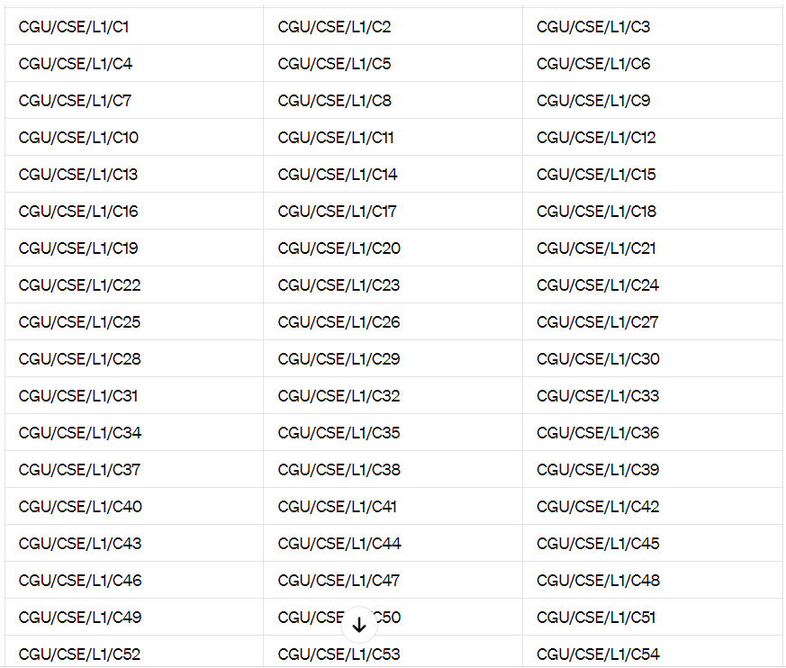





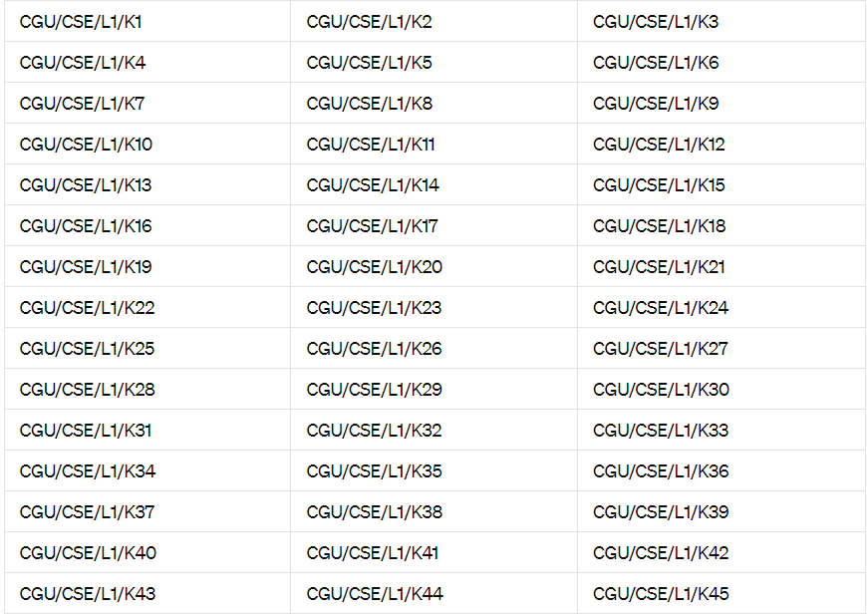

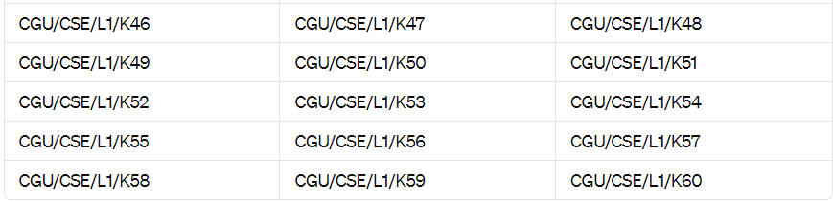

For mouse

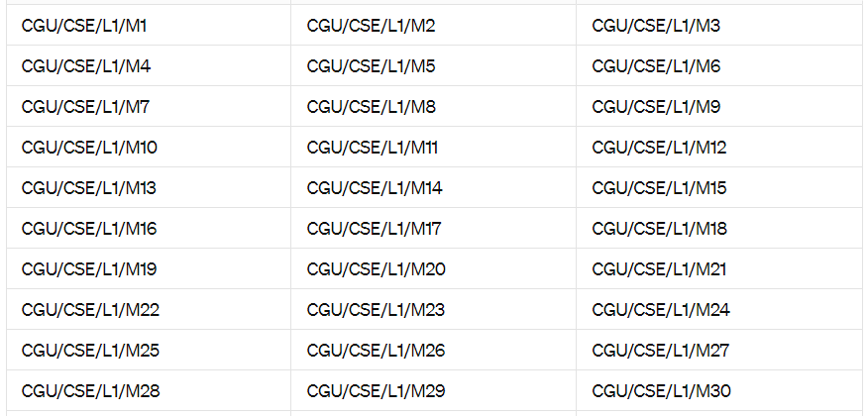

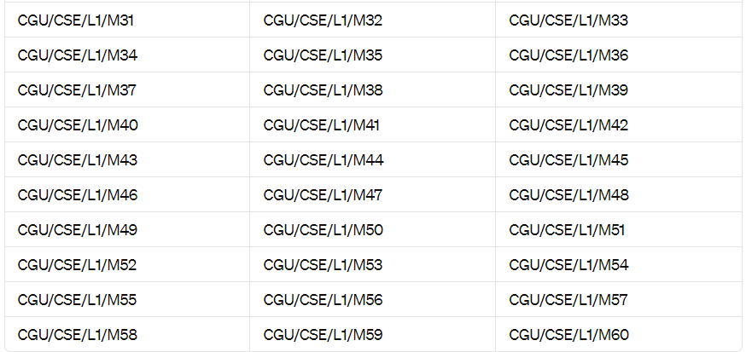

For ST LAB

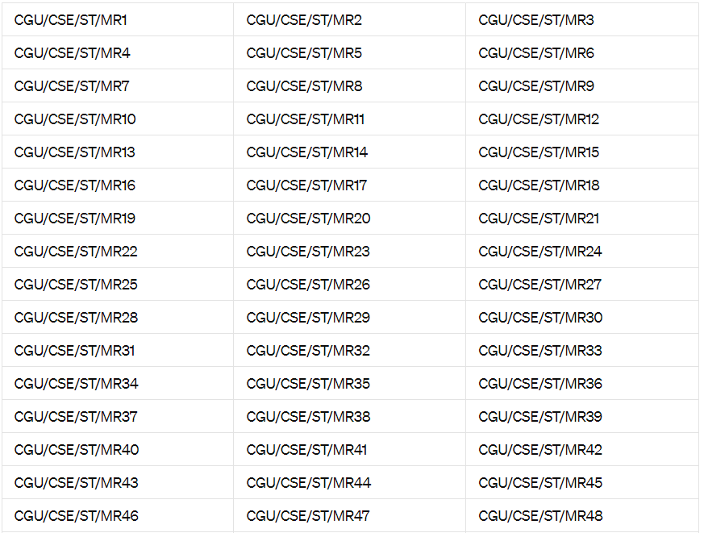

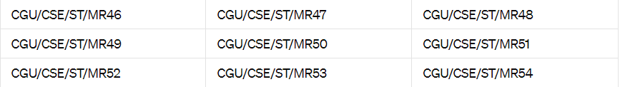

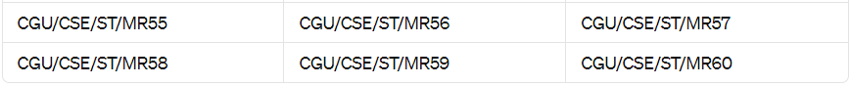

for Mouse

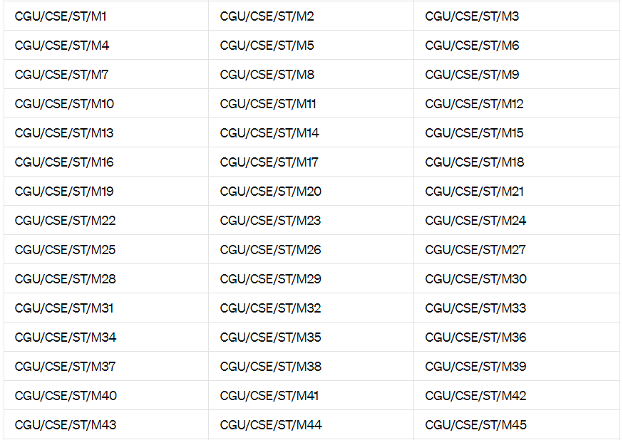

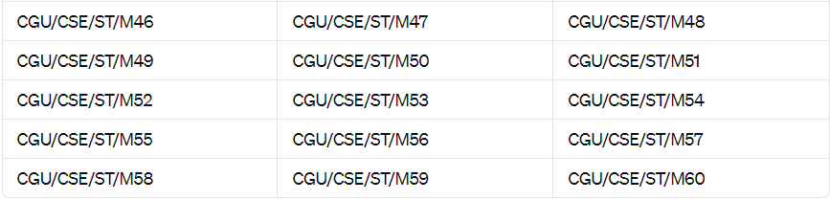

For keyboard

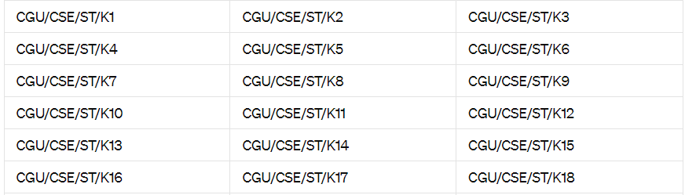

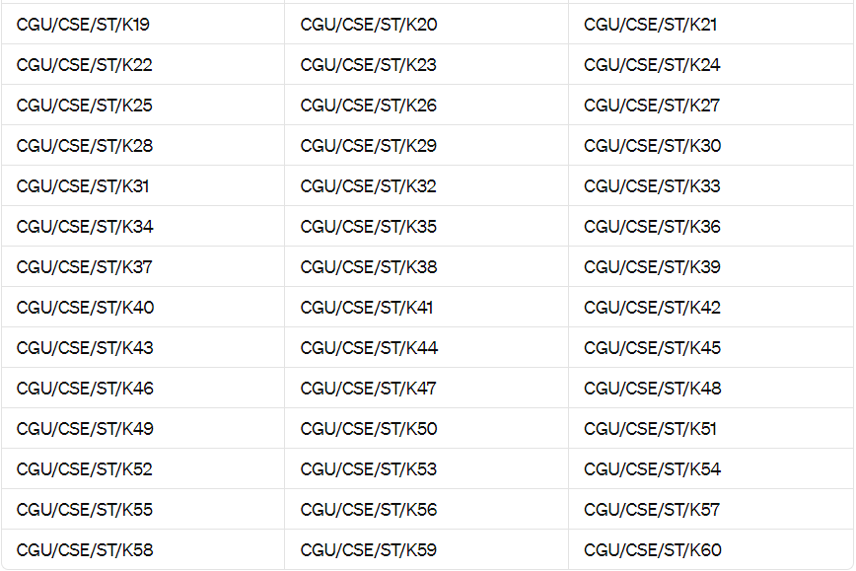

For CPU

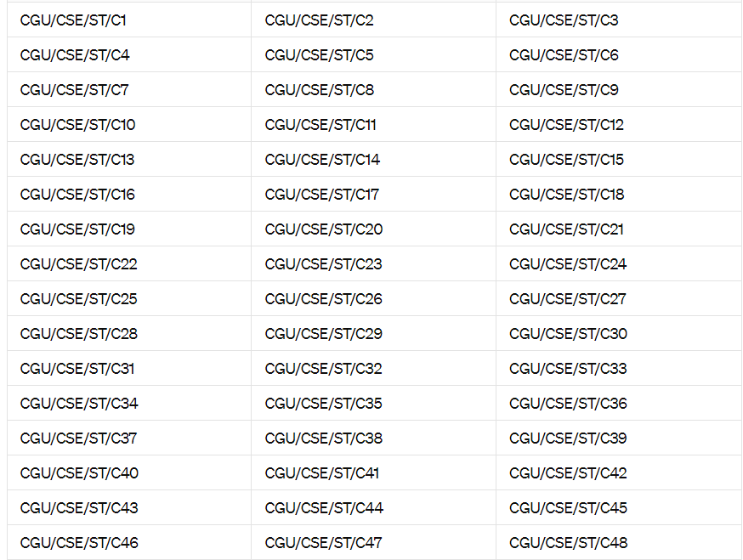

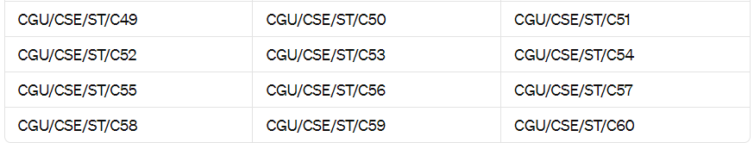

For PARAM

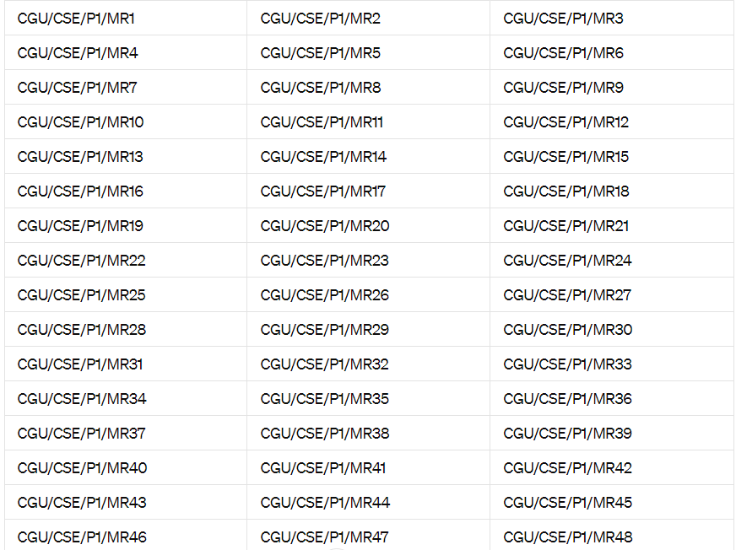

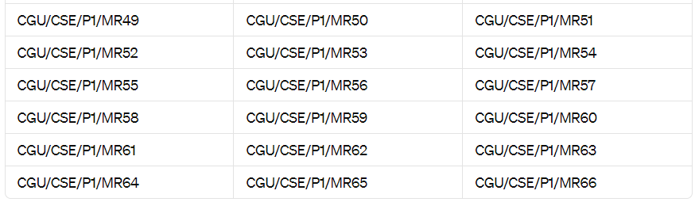

For mouse

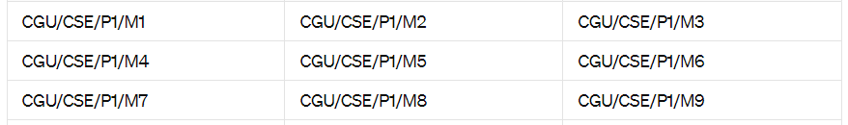

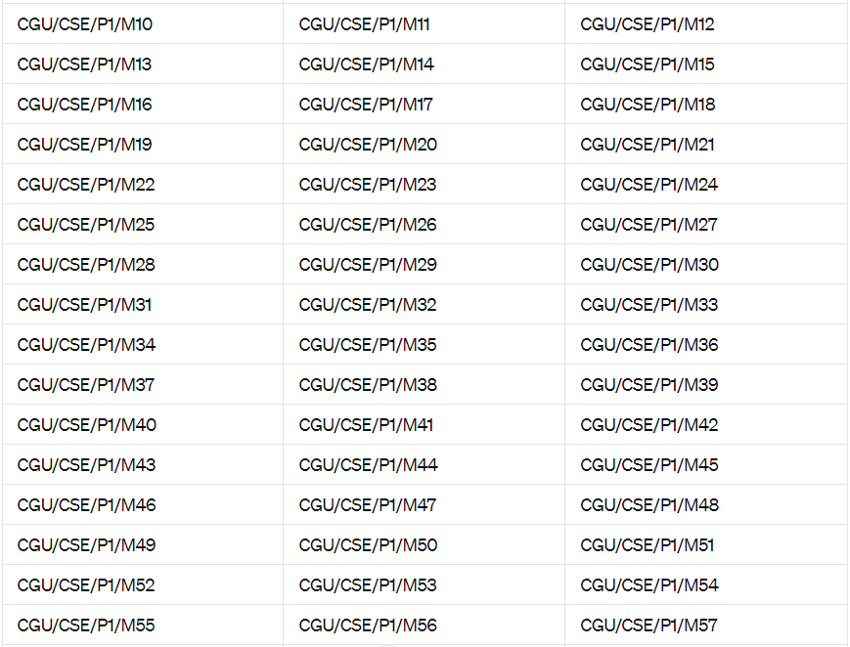

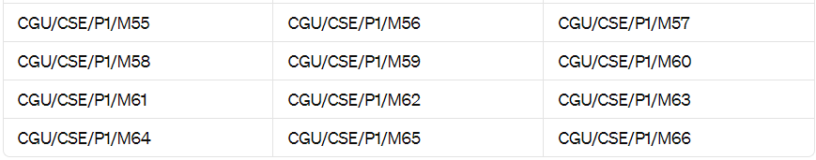

For keyboard

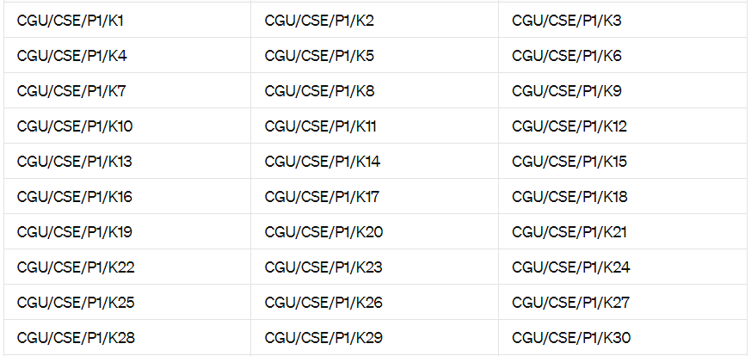

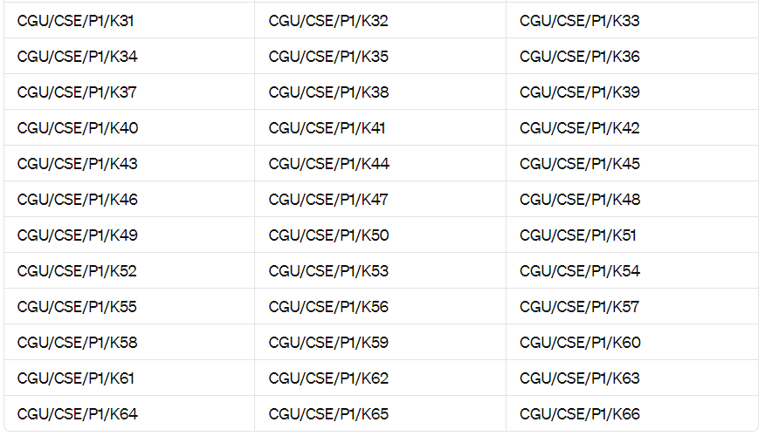FOR CPU

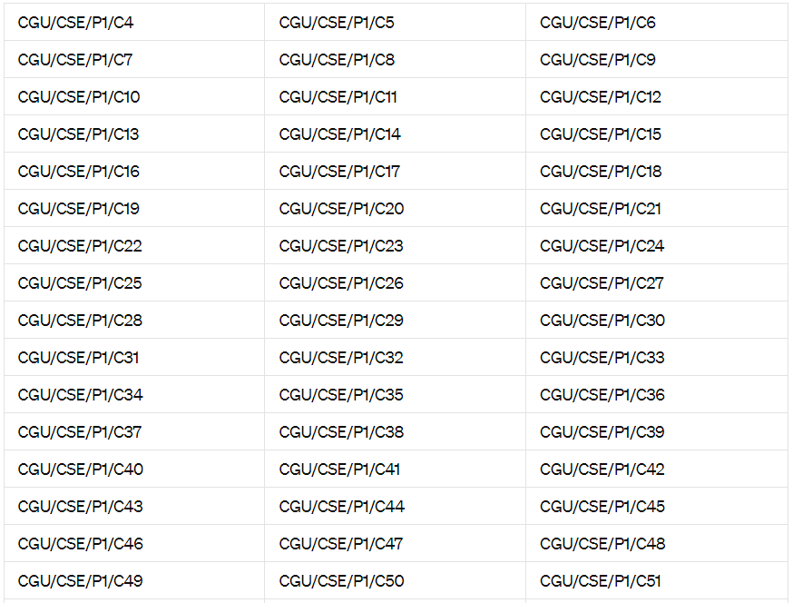

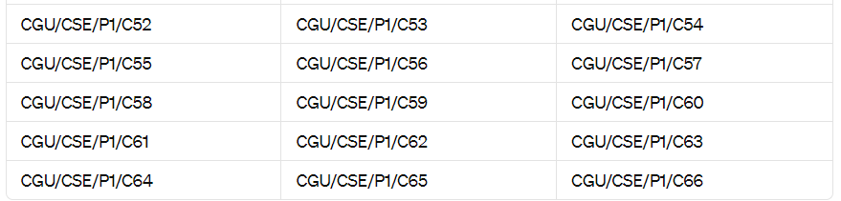

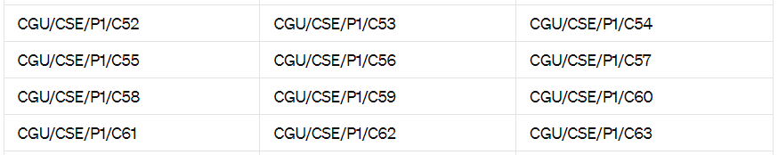

SCAPA LAB MONITOR

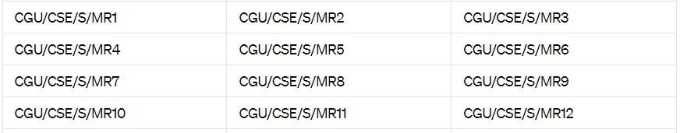

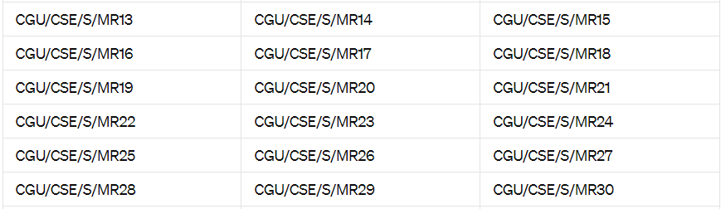

KEYBOARD

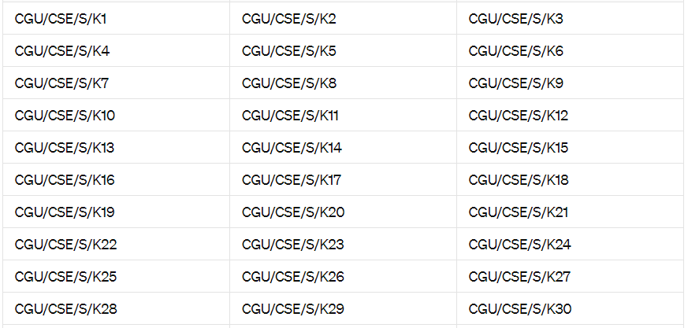

CPU

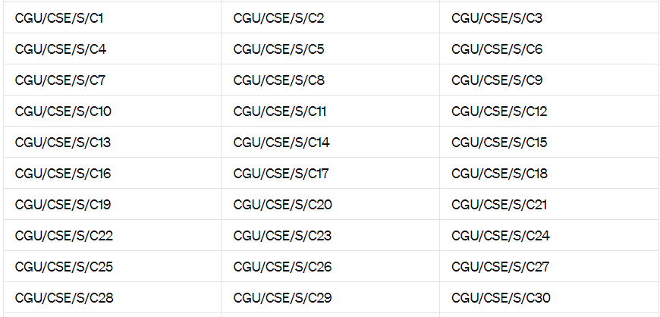

MOUSE



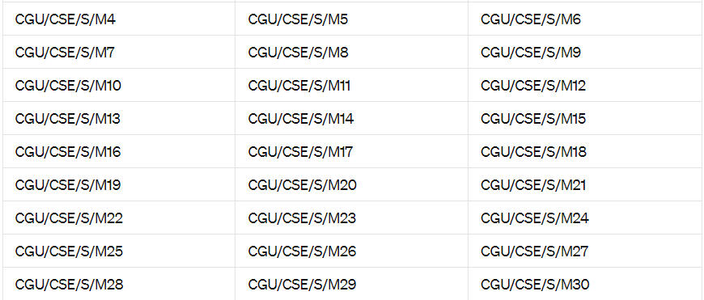

NETWORKING LAB

MONIROR

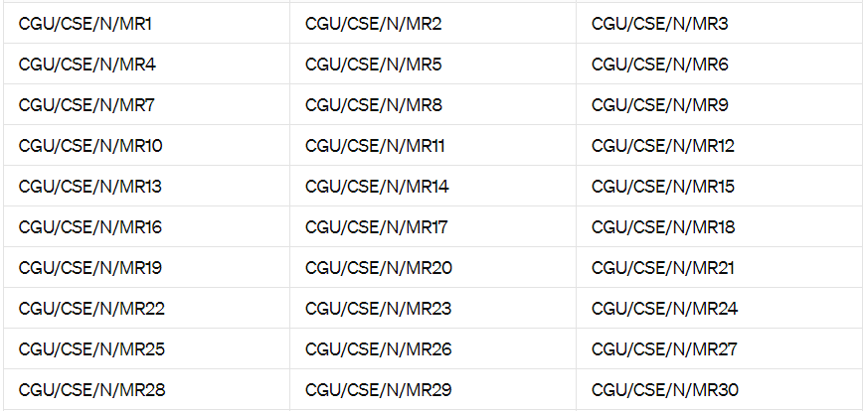

MOUSE

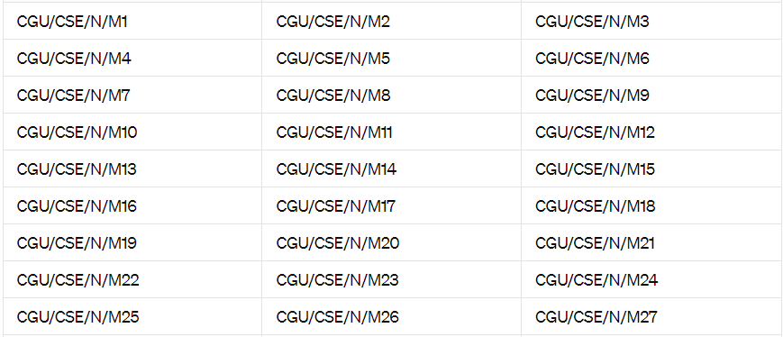



KEYBOARD

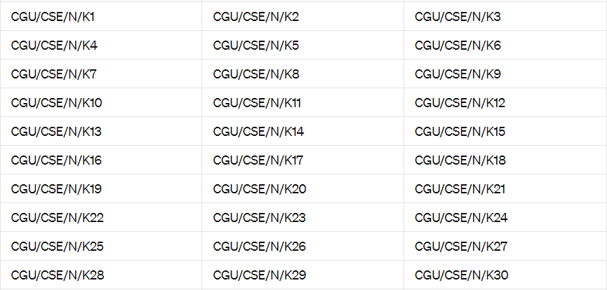

CPU

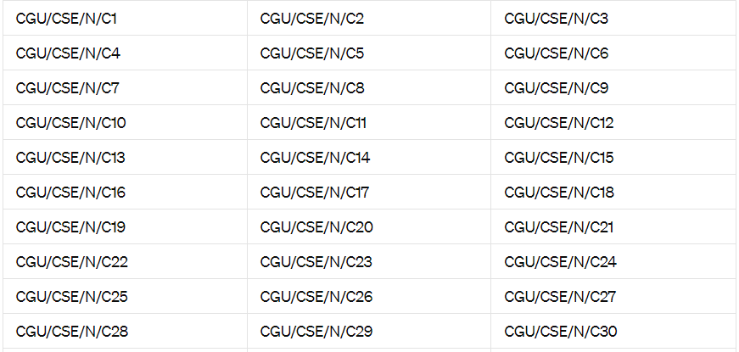

RESEARCH LAB

MONITOR

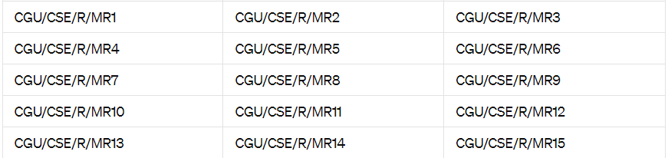

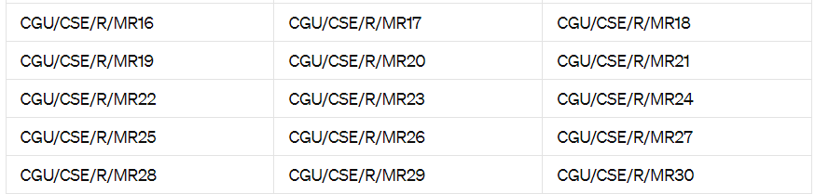

KEYBOARD

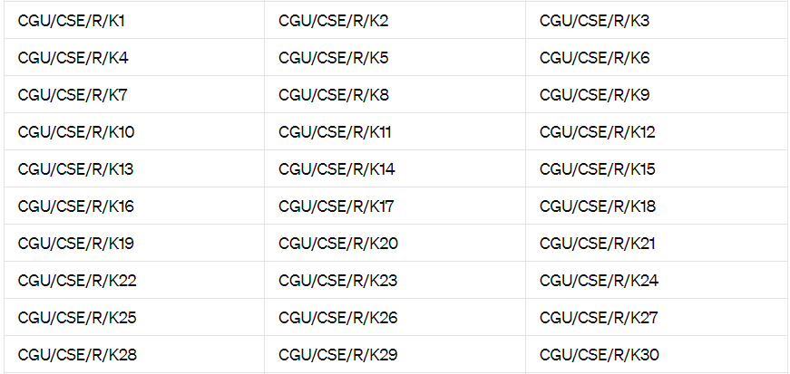

CPU

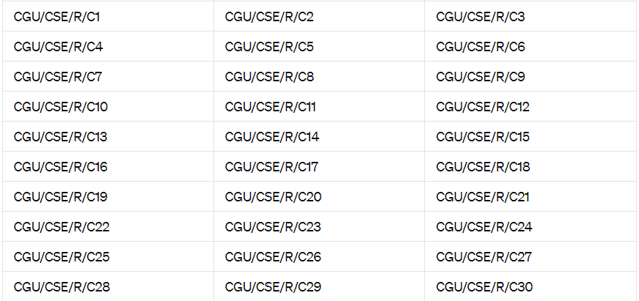

MOUSE

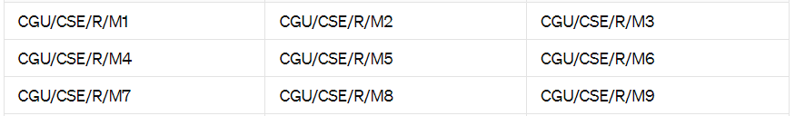

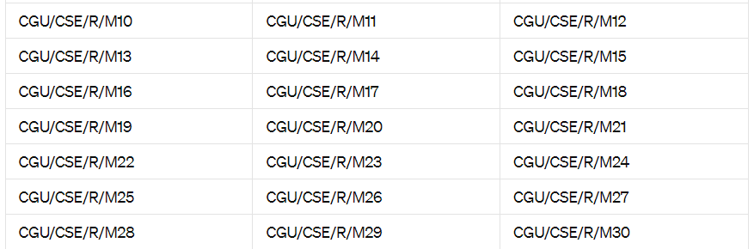

FOR IOT LAB

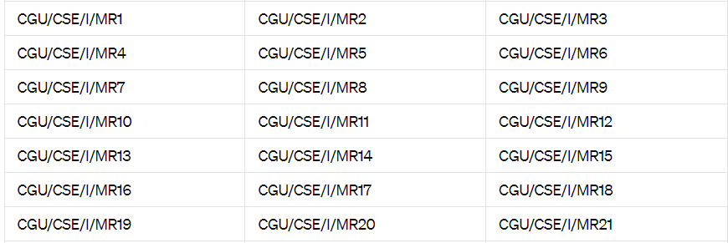

KEYBOARD

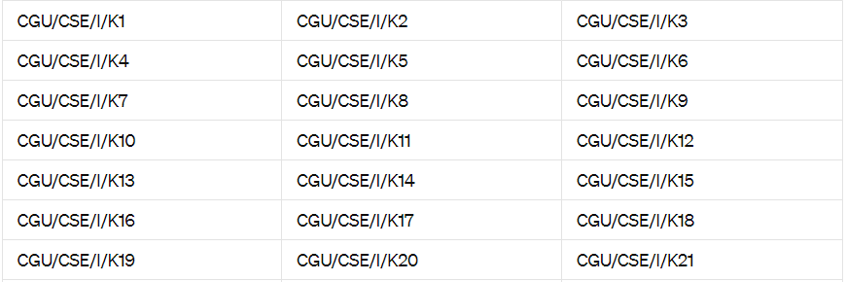

CPU

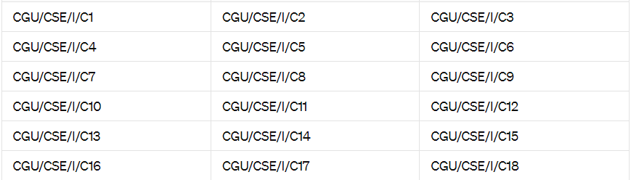



MOUSE

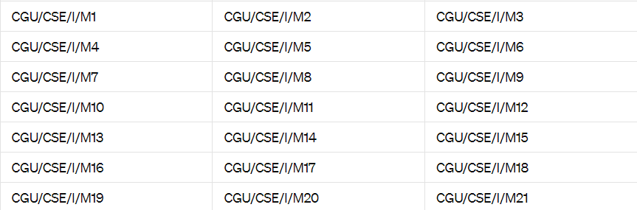

FOR LAB 2

MONITOR  
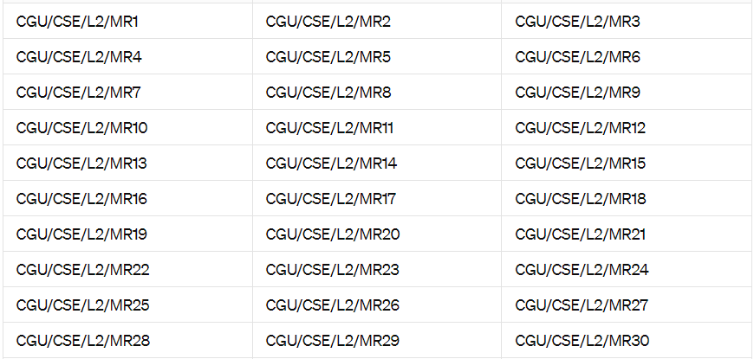

KEYOAED

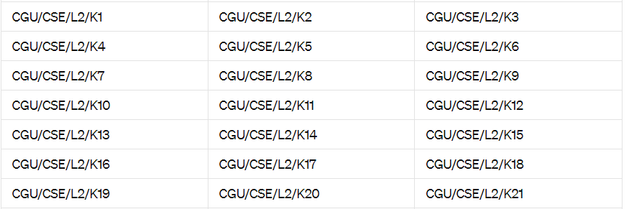



CPU

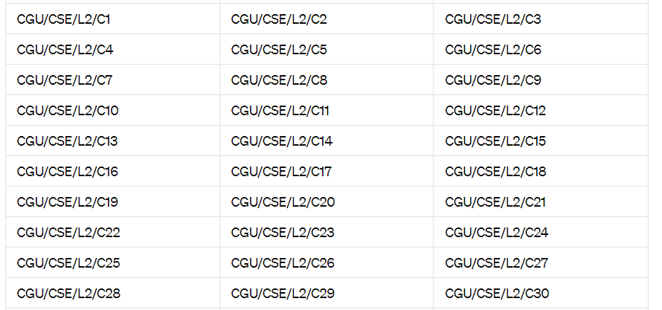

MOUSE

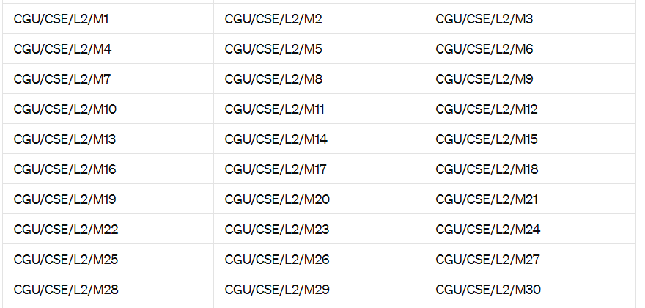

LAB3

MONITOR

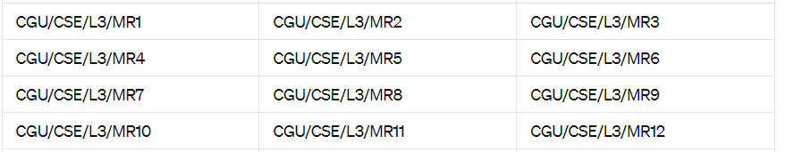

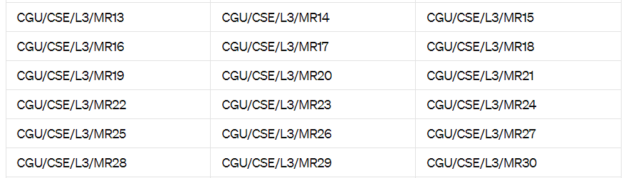

CPU

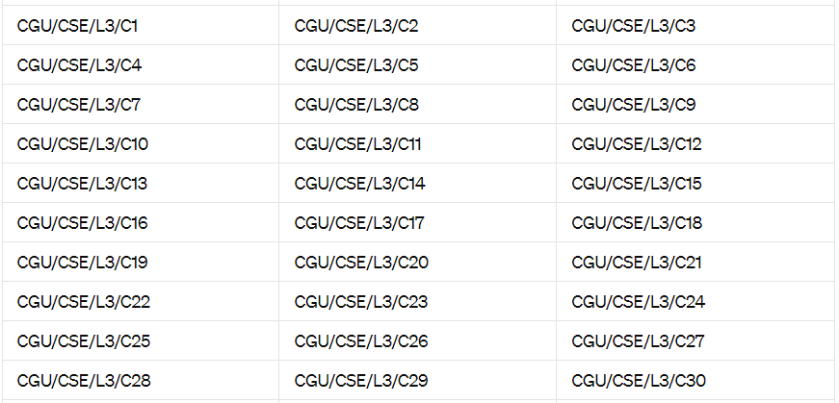

MOUSE

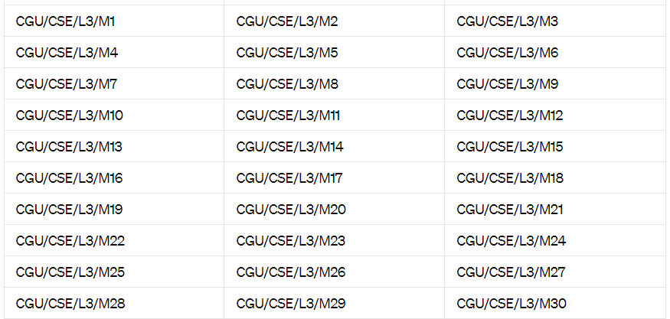

KEYBOARD



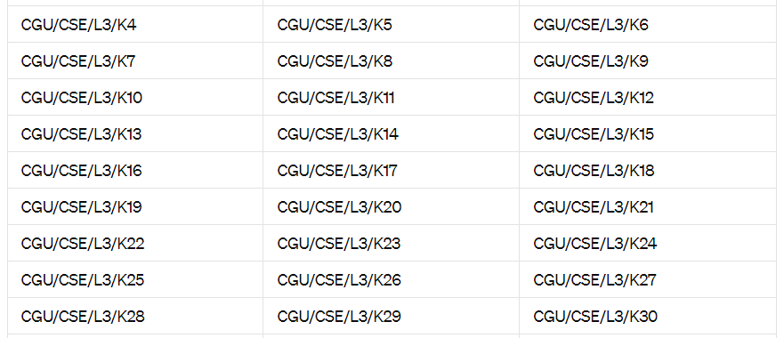

MOUSE

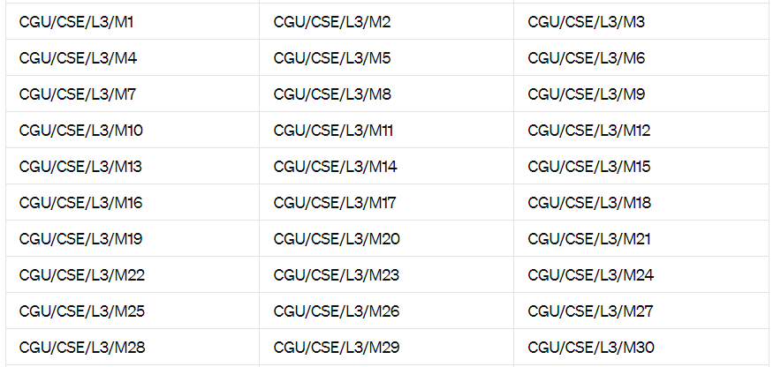

FOR LAB4

MONITOR

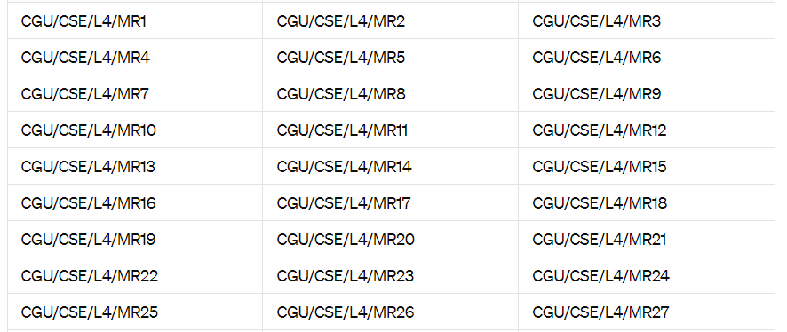

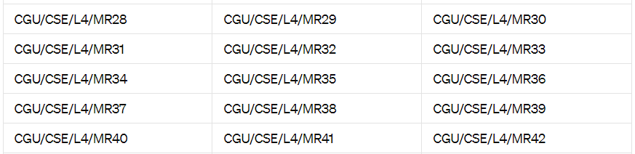

KEYBOARD

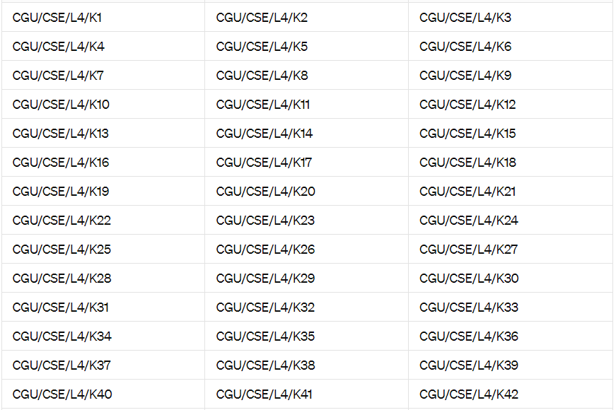

MOUSE

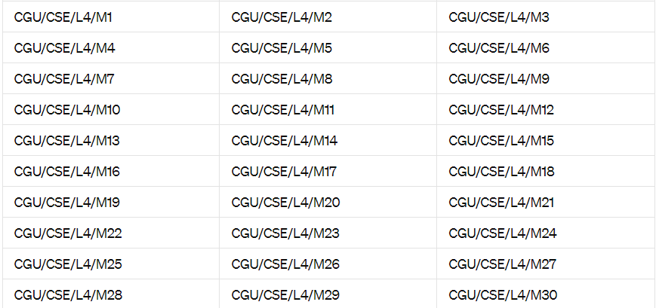

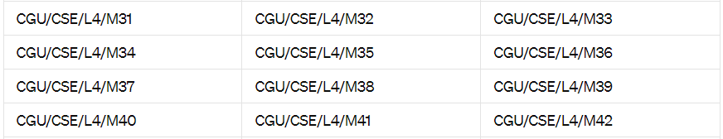

CPU

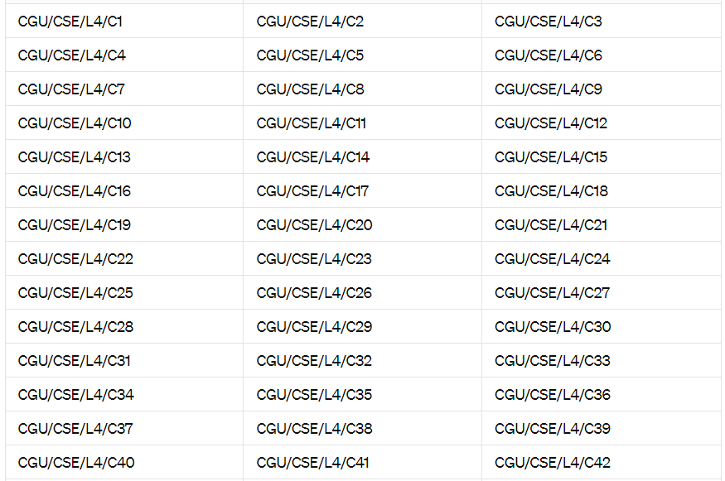

LAB5

MONITOR

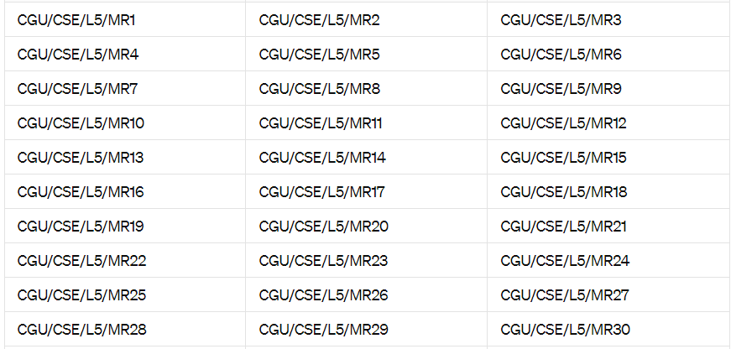

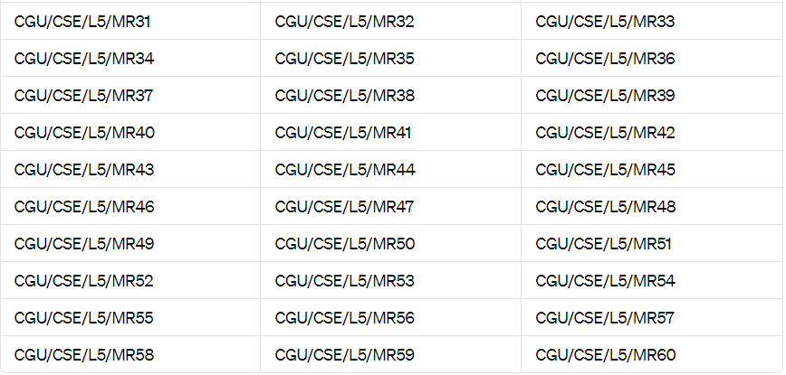

KETBOARD

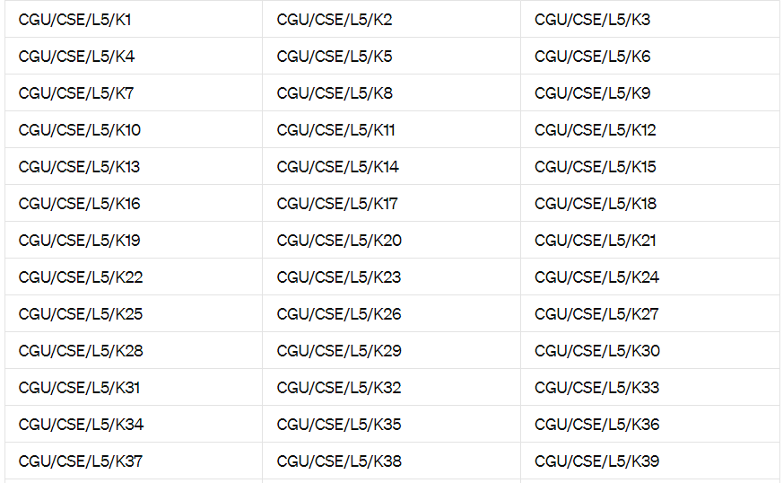

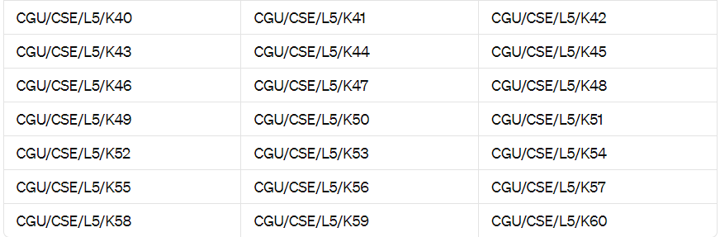

CPU

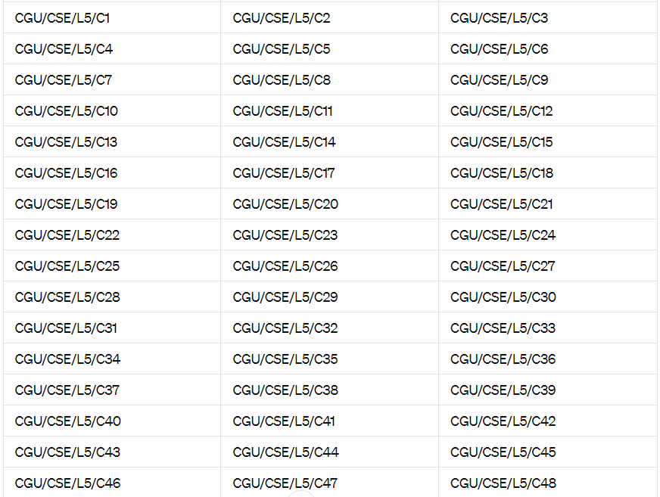

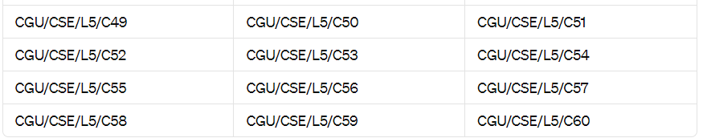

MOUSE

